A CASE-STUDY BASED REPORT
ON
Loan Default Prediction Using Random Forest and Gradient Boosting
submitted in partial fulfilment of the requirements for the Course
MACHINE LEARNING
BACHELOR OF TECHNOLOGY
in
A.Y.: 2026-27
by
M.Nishant 2520030323
M.Ram Ratan 2520030291
Under the Esteemed guidance of
Jyothsna Datti
Assistant Professor, Dept. of CSE




INDEX
Abstract
Introduction
Background
Motivation for the Project
Overview of the Work Carried Out
Scope and Responsible-Use Statement
Problem Statement
Case-Study Scenario
Central Case-Study Question
Formal Problem Definition
Objectives that Guide the Study
Assumptions and Limitations
Dataset and Exploratory Data Analysis
About the Dataset
Purpose of EDA
Preparation Steps Actually Performed
EDA Exploration - Implementation
Summary of EDA Findings
Algorithm Selection and Implementation

Conclusion

Abstract
Loan default prediction has become one of the most important applications of machine learning in the banking and financial sector. Financial institutions face significant challenges in identifying borrowers who may fail to repay their loans. Incorrect lending decisions can lead to substantial financial losses, increased operational risks, and reduced profitability. Traditional credit assessment techniques often rely on fixed rules and manual evaluation methods, which may not effectively capture complex relationships among borrower characteristics and loan attributes. This case study investigates the application of two powerful ensemble machine learning algorithms, Random Forest and Gradient Boosting, for predicting loan defaults. The study utilizes historical loan data containing borrower information such as annual income, employment details, loan amount, interest rate, credit history, and loan status. Various preprocessing techniques are applied to improve data quality and prepare the dataset for model training. The results demonstrate how machine learning can support banks in improving lending decisions, reducing default risks, and enhancing overall financial stability.
Introduction
Banks and lending organizations rely on accurate risk assessment before approving loans. Traditional evaluation methods are often time-consuming and may fail to capture hidden relationships within large datasets. Machine learning techniques enable automated identification of complex patterns related to borrower behaviour and repayment history, making loan risk prediction more reliable.
Motivation for the Project
The increasing volume of loan applications requires faster and more accurate evaluation methods. Identifying high-risk borrowers at an early stage can reduce financial losses, improve operational efficiency, and support responsible lending practices. Machine learning techniques offer a data-driven approach by learning patterns from historical borrower information. The motivation behind this project is to explore how these techniques can improve credit risk assessment and support informed lending decisions.
Overview of the Work Carried Out
The study began with understanding the problem domain and identifying key challenges associated with loan default prediction. Relevant borrower and loan information was analyzed and prepared through preprocessing techniques. After understanding the dataset structure, machine learning models were developed using Random Forest and Gradient Boosting algorithms. The trained models were evaluated using multiple performance metrics and compared to determine the most suitable approach for practical loan default prediction.
Scope and Responsible-Use Statement
The scope of this project is limited to predicting loan default risk using available dataset features. The developed models are intended to assist financial institutions in decision making rather than replacing human judgment. Responsible use of predictive models is essential because automated decisions may be influenced by patterns present in historical data. Privacy, fairness, transparency, and regulatory considerations must be maintained while interpreting the results generated by the system.

Problem Statement
Case-Study Scenario
Consider a financial institution that processes thousands of loan applications every month. Each applicant has unique financial characteristics, employment backgrounds, and credit histories. Evaluating every application manually is time-consuming and prone to inconsistencies. The institution therefore seeks an intelligent system capable of analyzing historical loan records and predicting the likelihood of borrower default. Such a system can improve lending efficiency and strengthen risk management practices.
Central Case-Study Question
Can machine learning algorithms accurately predict whether a borrower is likely to default on a loan? Among the selected ensemble learning techniques, Random Forest and Gradient Boosting, which algorithm provides superior predictive performance and better support for credit risk assessment?
Formal Problem Definition
The loan default prediction task can be formulated as a supervised binary classification problem. Given a set of borrower attributes such as annual income, loan amount, employment status, credit history, and interest rate, the objective is to predict whether the borrower will repay the loan or default. The trained classifier is then used to predict default risk for new applicants based on their financial profiles.
Objectives that Guide the Study
To understand factors influencing loan repayment behavior. 2. To prepare and preprocess the dataset. 3. To implement Random Forest and Gradient Boosting algorithms. 4. To evaluate model performance using Accuracy, Precision, Recall, F1-Score, and ROC-AUC. 5. To identify the most effective model for loan default prediction. 6. To demonstrate the practical usefulness of machine learning in financial risk management.
Assumptions and Limitations
The study assumes that the dataset accurately represents real-world loan behavior and contains sufficient information for prediction. However, the model performance depends heavily on data quality and feature availability. Economic changes and variations in borrower behavior can influence the reliability of predictions. Therefore, results should be interpreted within the context of the available dataset.
Dataset and Exploratory Data Analysis
About the Dataset
The Loan Default Dataset used in this case study is sourced from Kaggle, contributed by M Yasser H. It contains 148,670 loan application records described by 34 attributes, including borrower demographics (age, gender), loan characteristics (loan amount, loan type, loan purpose, term), financial indicators (rate of interest, upfront charges, loan-to-value ratio, debt-to-income ratio), credit information (credit score, credit worthiness, credit type), and property details (property value, occupancy type, construction type). The target variable, Status, is a binary label indicating whether a loan resulted in default (1) or was repaid without default (0). The dataset reflects real-world lending patterns and is moderately imbalanced, with roughly 75% non-default and 25% default records, making it well-suited for evaluating ensemble classification algorithms such as Random Forest and Gradient Boosting on a realistic credit-risk prediction task.
Purpose of EDA
Exploratory Data Analysis (EDA) is a foundational phase in the data science lifecycle. It involves analyzing, visualizing, and summarizing a dataset to understand its underlying structure, main characteristics, and potential anomalies before applying formal modeling or hypothesis-testing techniques.
Preparation Steps Actually Performed
A. Understanding Dataset Structure and Integrity
Assessment: Detecting missing values, structural inconsistencies, and duplicate records that require cleaning or imputation.
B. Analyzing Feature Distributions and Outliers
Shape of the Data: Examining whether numerical features are normally distributed, skewed, or multi-modal, which influences downstream preprocessing choices.
Outlier Detection: Isolating extreme values or anomalies that could skew statistical measures and degrade machine learning model performance.
C. Investigating Target Class Balance
Imbalance Identification: Evaluating the distribution of the target variable (e.g., `Status` in credit risk classification). Understanding class imbalance (such as a 75% vs. 25% split) is critical because it dictates the selection of appropriate model evaluation metrics (such as Precision, Recall, F1-Score, and ROC-AUC) over simple accuracy.
D. Identifying Relationships and Multicollinearity
Bivariate and Multivariate Correlations: Mapping relationships between independent variables and the target variable to uncover potential predictive signals.
Collinearity Check: Spotting highly correlated features (e.g., `loan_amount` and `property_value`) to prevent multicollinearity issues in linear and logistic regression models.
E. Formulating Hypotheses and Feature Engineering Strategies
Domain Validation: Confirming whether expected business hypotheses (e.g., "lower credit scores correspond to higher default rates") are reflected in the raw data.
Informing Model Pipelines: Laying the groundwork for strategic data splitting, target encoding, and specific imputation strategies (such as median-filling for skewed columns) to avoid data leakage.
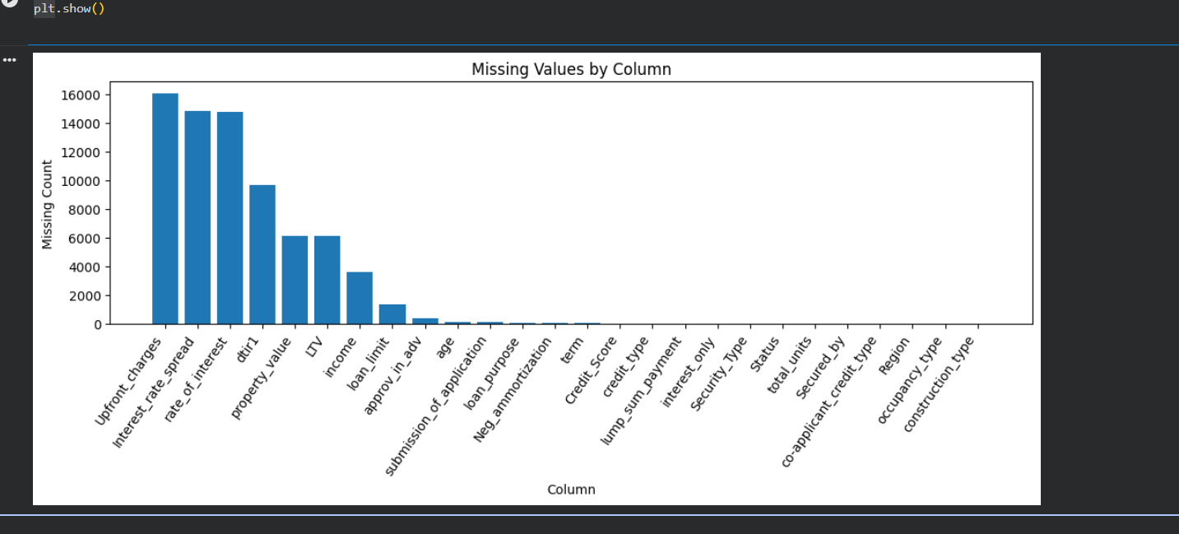

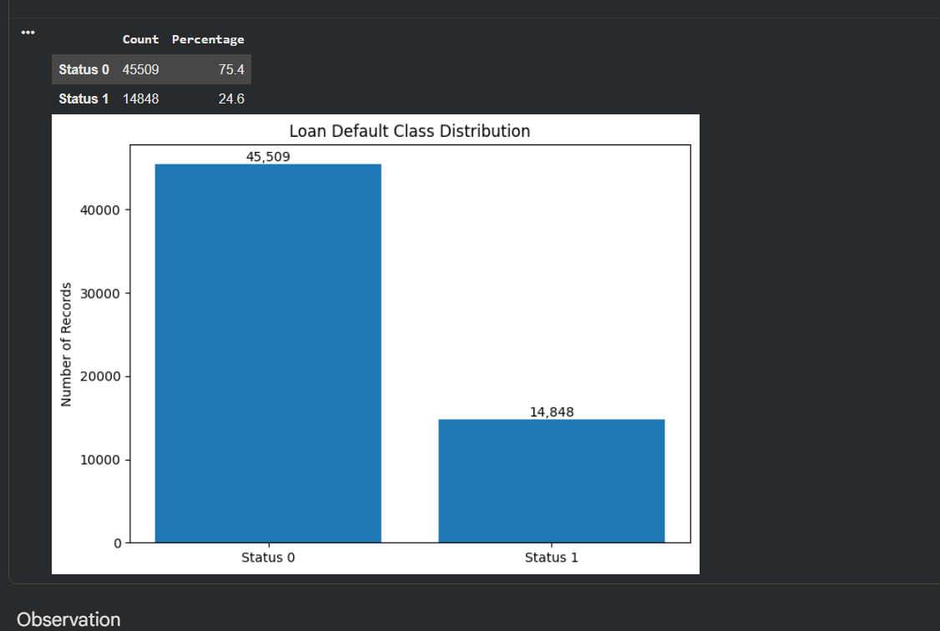

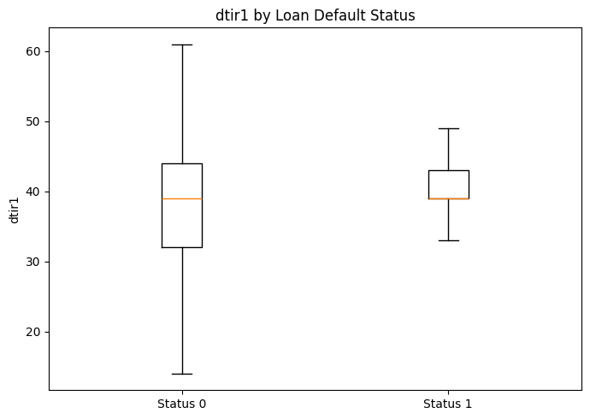
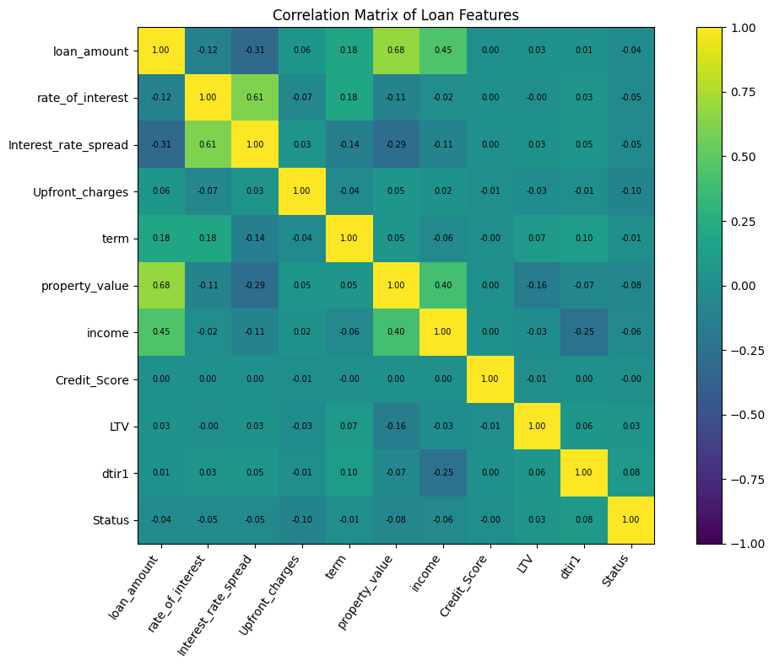
EDA Exploration - Implementation
To ensure a rigorous, reproducible, and leak-free machine learning workflow, the EDA phase was implemented using a systematic programming and visualization pipeline:
- Environment & Library Setup: The implementation leverages standard scientific Python libraries: pandas for structural data manipulation, numpy for vectorized mathematical operations, and matplotlib alongside seaborn for generating publication-quality static visualizations.
- Data Integrity & Copy Isolation: To prevent accidental modification of the source file, the raw dataset was preserved as df_raw, and a separate, independent DataFrame copy (df) was instantiated specifically for exploration and visualization.
- Handling Incomplete Records & Unknowns:
  - For categorical features containing missing labels (such as demographic or credit-type fields), missing values were encoded under a distinct brand-new category called "Unknown" to preserve their statistical distribution without losing rows.
  - For numerical features, missing values were imputed using the feature's column-wise median to minimize the skewing influence of potential outliers. (Note: For production modeling, fit-imputations are configured within a pipeline transformer strictly on training splits to prevent data leakage).
- Feature-Target Cross-Analysis: Implementation included bivariate cross-tabulations (using pd.crosstab normalized across indexes) to directly calculate the empirical default percentages within individual categorical bins, and split-histograms/boxplots to isolate numerical behaviors across Status 0 (non-default) and Status 1 (default).

Summary of EDA Findings
Following the implementation of the exploratory pipeline, several critical insights were extracted from the dataset:
A. Structural & Missing Value Constraints
- High Dimensionality: The source dataset is highly comprehensive, containing 60,357 records and 34 attributes.
- High Missingness in Financial Indicators: Upfront charges, interest rate spread, and interest rates have the highest proportion of missing entries. This indicates that default prediction models must be highly robust to missing data patterns or utilize advanced tree-based algorithms (like XGBoost or LightGBM) that natively handle missing splits.
B. Moderate Target Class Imbalance
- The default rate in this analytical subset hovers around 24.6% (Status 1) against 75.4% (Status 0).
- Analytical Implication: Because of this moderate class imbalance, standard accuracy is an inadequate metric of model success. The final model evaluation must rely heavily on Recall (to capture as many true defaults as possible), Precision (to minimize false alarms on creditworthy applicants), and F1-Score / ROC-AUC to balance classification thresholds.
C. Key Numerical Discriminators
- Loan-to-Value (LTV) Risk: Borrowers who defaulted (Status 1) exhibited significantly higher average and median Loan-to-Value ratios compared to performing accounts. High LTV implies thin collateral cushioning, representing higher systemic risk.
- Debt-to-Income (DTI/dtir1) Pressure: Higher debt-to-income values are visibly shifted towards the default class, confirming that tight borrower cash flow directly correlates with credit distress.
- Credit Score Flatness: Surprisingly, the distribution of raw credit scores is relatively flat across both classes within this dataset segment, suggesting that credit scores alone may not be a silver bullet and must be evaluated in tandem with transactional and loan-specific properties (e.g., LTV, loan type) to achieve strong predictive separation.
D. Categorical Risk Indicators
- Age Trends: Default rates show subtle increases as age brackets rise, with extreme variations noted in groups with missing or unrecorded age values.
- Loan Type & Purpose Variations: Empirical default rates vary significantly depending on the selected loan_type (e.g., certain specialized types show a default rate exceeding 34%), highlighting the critical need to include categorical encoding schemes such as target encoding or one-hot encoding in the training pipeline.

Algorithm Selection and Implementation
Random Forest and Gradient Boosting were selected because both belong to the ensemble learning family and have demonstrated strong performance in classification problems. Random Forest combines predictions from multiple decision trees, reducing variance and improving generalization. Gradient Boosting constructs models sequentially, where each new model learns from errors made by previous models. Both models were implemented using Scikit-learn and evaluated using standard classification metrics. Their comparative analysis helps determine the most suitable approach for loan default prediction and financial risk assessment.
Conclusion
This case study explored the use of machine learning techniques for predicting loan defaults using borrower and loan-related information. Through preprocessing and model development, valuable insights were obtained regarding factors influencing repayment behavior. Both Random Forest and Gradient Boosting demonstrated the ability to classify borrowers effectively and support credit risk assessment. The study highlights how machine learning can enhance lending operations, reduce default risks, and improve financial decision making within banking institutions.
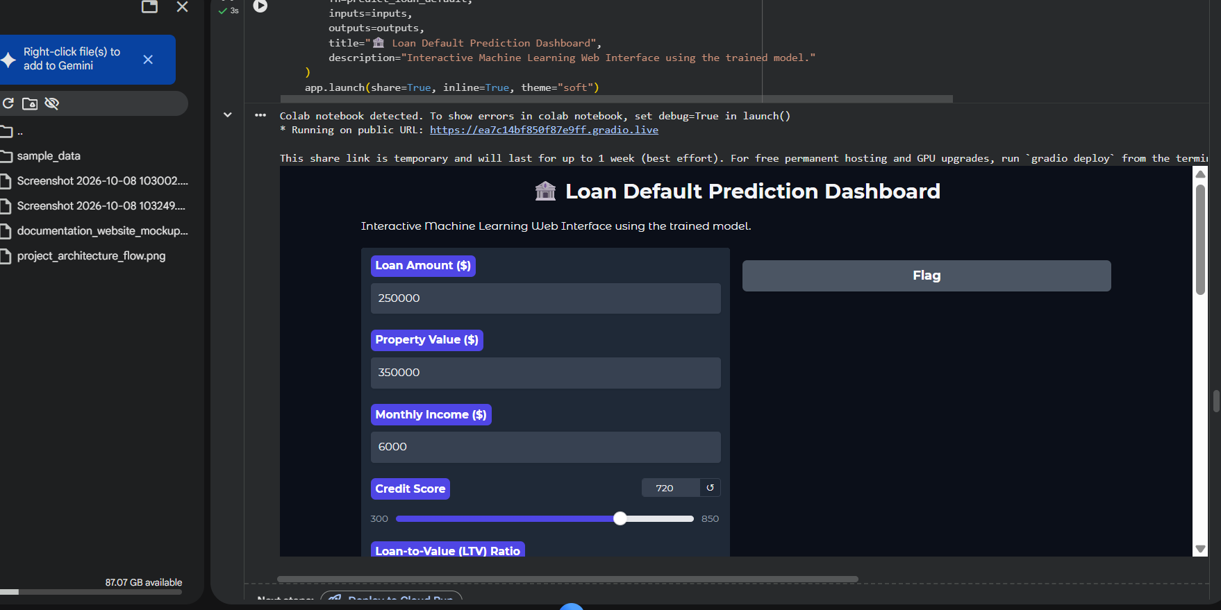

Signature of the Team members

